Data Analytics (DA)
Module-End -3
Module End Assignment:
“Analysing E-Learning Platform Purchases using MySQL”

CREATE THE DATABASE AND SCHEMA

Create a Database for this project
INPUT:
CREATE DATABASE elearning_db;
USE elearning_db;

OUTPUT:

Create all three tables
INPUT:
-- Learners Table
CREATE TABLE learners (
learner_id INT PRIMARY KEY,
full_name VARCHAR(100),
country VARCHAR(50)
);

-- Courses Table
CREATE TABLE courses (
course_id INT PRIMARY KEY,
course_name VARCHAR(100),
category VARCHAR(50),
unit_price DECIMAL(10,2)
);

-- Purchases Table
CREATE TABLE purchases (
purchase_id INT PRIMARY KEY,
learner_id INT,
course_id INT,
quantity INT,
purchase_date DATE,

FOREIGN KEY (learner_id) REFERENCES learners(learner_id),
FOREIGN KEY (course_id) REFERENCES courses(course_id)
);
OUTPUT:

TABLE – WISE ATTRIBUTES

LEARNERS TABLE:
Column Name | Data Type | Constraint | Description
learner_id | INT | PRIMARY KEY | Unique ID for each learner
full_name | VARCHAR(100) | NOT NULL | Name of the learner
country | VARCHAR(50) | NOT NULL | Country of the learner

COURSES TABLE:
Column Name | Data Type | Constraint | Description
course_id | INT | PRIMARY KEY | Unique ID for each course
course_name | VARCHAR(100) | NOT NULL | Course title
category | VARCHAR(50) | NOT NULL | Course category
unit_price | DECIMAL(10,2) | NOT NULL | Price of one course

PURCHASE TABLE:
Column Name | Data Type | Constraint | Description
purchase_id | INT | PRIMARY KEY | Unique purchase ID
learner_id | INT | FOREIGN KEY | References learners table
course_id | INT | FOREIGN KEY | References courses table
quantity | INT | NOT NULL | Number of courses purchased
purchase_date | DATE | NOT NULL | Date of purchase

Relationship diagram between all three tables:
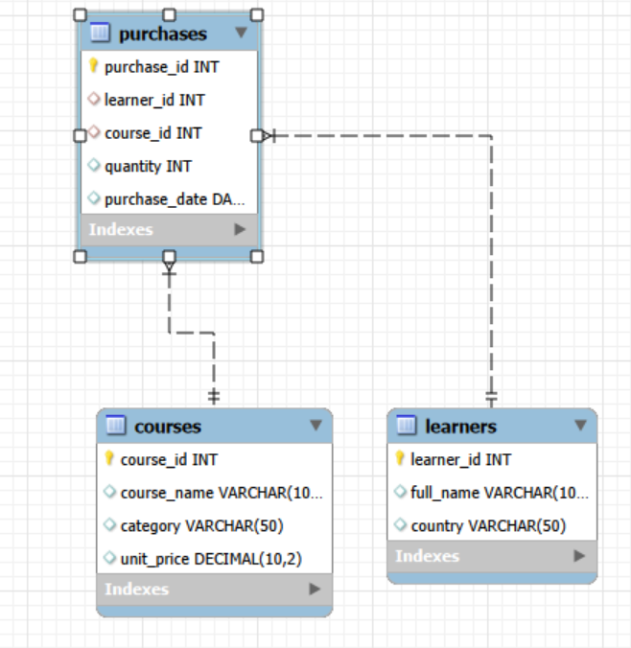

INSERTING DATA VALUES INTO TABLES:
LEARNER TABLE VALUES
INPUT:
INSERT INTO learners VALUES
(1,'Arjun Kumar','India'),
(2,'Maria Lopez','Spain'),
(3,'John Smith','USA'),
(4,'Aisha Khan','UAE'),
(5,'David Lee','Singapore');

COURSES TABLE VALUES
INPUT:
INSERT INTO courses VALUES
(101,'SQL for Beginners','Data Analytics',120.00),
(102,'Python Programming','Programming',150.00),
(103,'Digital Marketing Basics','Marketing',100.00),
(104,'Advanced Excel','Data Analytics',90.00),
(105,'Graphic Design Fundamentals','Design',110.00);

PURCHASES TABLE VALUES
INPUT:
INSERT INTO purchases VALUES
(1,1,101,1,'2025-01-05'),
(2,2,102,2,'2025-01-10'),
(3,3,103,1,'2025-01-15'),
(4,1,104,3,'2025-01-20'),
(5,4,101,2,'2025-01-25'),
(6,5,102,1,'2025-02-01'),
(7,2,103,2,'2025-02-05'),
(8,3,104,1,'2025-02-10');
OUTPUT OF ALL THREE TABLE VALUES:

DATA EXPLORATION USING JOINS
INNER JOINS:
INPUT:
SELECT
l.full_name AS learner_name,
c.course_name,
c.category,
p.quantity,
FORMAT(p.quantity * c.unit_price,2) AS total_amount,
p.purchase_date
FROM purchases p
INNER JOIN learners l
ON p.learner_id = l.learner_id
INNER JOIN courses c
ON p.course_id = c.course_id
ORDER BY total_amount DESC;

OUTPUT:
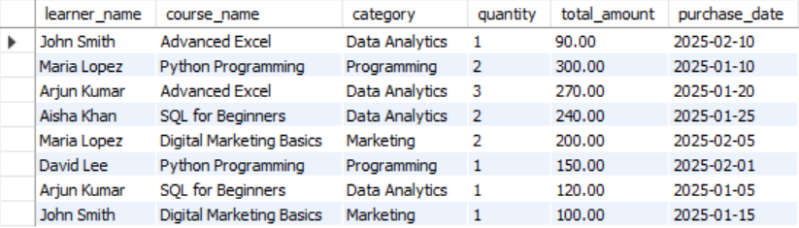

LEFT JOIN:

INPUT:
SELECT
l.full_name,
c.course_name,
p.quantity
FROM learners l
LEFT JOIN purchases p
ON l.learner_id = p.learner_id
LEFT JOIN courses c
ON p.course_id = c.course_id;

OUTPUT:
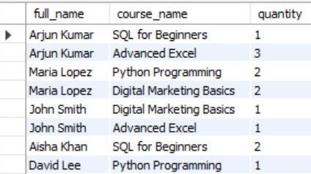

RIGHT JOIN

INPUT:
SELECT
l.full_name,
c.course_name,
p.quantity
FROM learners l
RIGHT JOIN purchases p
ON l.learner_id = p.learner_id
RIGHT JOIN courses c
ON p.course_id = c.course_id;

OUTPUT:


ANALYTICAL QUERIES
Each Learner’s Total Spending
INPUT:
SELECT
l.full_name,
l.country,
FORMAT(SUM(p.quantity * c.unit_price),2) AS total_spent
FROM purchases p
JOIN learners l
ON p.learner_id = l.learner_id
JOIN courses c
ON p.course_id = c.course_id
GROUP BY l.full_name, l.country
ORDER BY total_spent DESC;

OUTPUT:
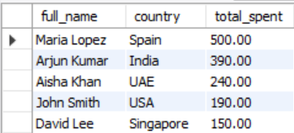

Top 3 Most Purchased Courses

INPUT:
SELECT
c.course_name,
SUM(p.quantity) AS total_quantity_sold
FROM purchases p
JOIN courses c
ON p.course_id = c.course_id
GROUP BY c.course_name
ORDER BY total_quantity_sold DESC
LIMIT 3;

OUTPUT:
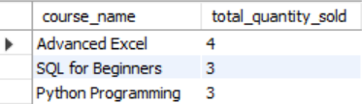

Each course category’s total revenue and the number of unique learners who purchased from that category.
INPUT:
SELECT
c.category,
FORMAT(SUM(p.quantity * c.unit_price),2) AS total_revenue,
COUNT(DISTINCT p.learner_id) AS unique_learners
FROM purchases p
JOIN courses c
ON p.course_id = c.course_id
GROUP BY c.category
ORDER BY total_revenue DESC;

OUTPUT:
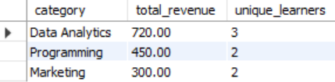

Learners Purchasing From More Than One Category

INPUT:
SELECT
l.full_name,
COUNT(DISTINCT c.category) AS categories_purchased
FROM purchases p
JOIN learners l
ON p.learner_id = l.learner_id
JOIN courses c
ON p.course_id = c.course_id
GROUP BY l.full_name
HAVING COUNT(DISTINCT c.category) > 1;

OUTPUT:
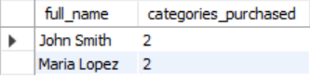

Courses Not Purchased
INPUT:
SELECT
c.course_name
FROM courses c
LEFT JOIN purchases p
ON c.course_id = p.course_id
WHERE p.purchase_id IS NULL;

OUTPUT:


SUMMARY REPORT

This project analysed purchase data from an online learning platform using MySQL. The database contained three tables: learners, courses, and purchases. SQL queries were used to explore purchasing behaviour, identify top-selling courses, and evaluate revenue by category.
Key Insights
- Top Spending Learners:
Some learners purchased multiple courses, resulting in higher total spending. These learners represent valuable repeat customers for the platform.
- Most Popular Courses:
Courses such as Python Programming and SQL for Beginners had the highest purchase quantities, indicating strong interest in technical and data-related skills.
- Top Revenue Categories:
The Data Analytics category generated the highest revenue due to multiple course purchases and strong learner demand.
- Cross-Category Learners:
Several learners purchased courses from more than one category, suggesting opportunities for cross-selling and bundle offers.
- Courses with No Purchases:
Some courses had no purchases, indicating either low visibility or low demand.
Recommendations
- Focus marketing efforts on high-performing categories like Data Analytics and Programming.
- Offer bundle discounts for learners purchasing courses across multiple categories.
- Promote low-performing courses through targeted advertising or special offers.
- Encourage repeat purchases by offering loyalty rewards or personalized recommendations.

